Stories from the Chinese Apostolate #1

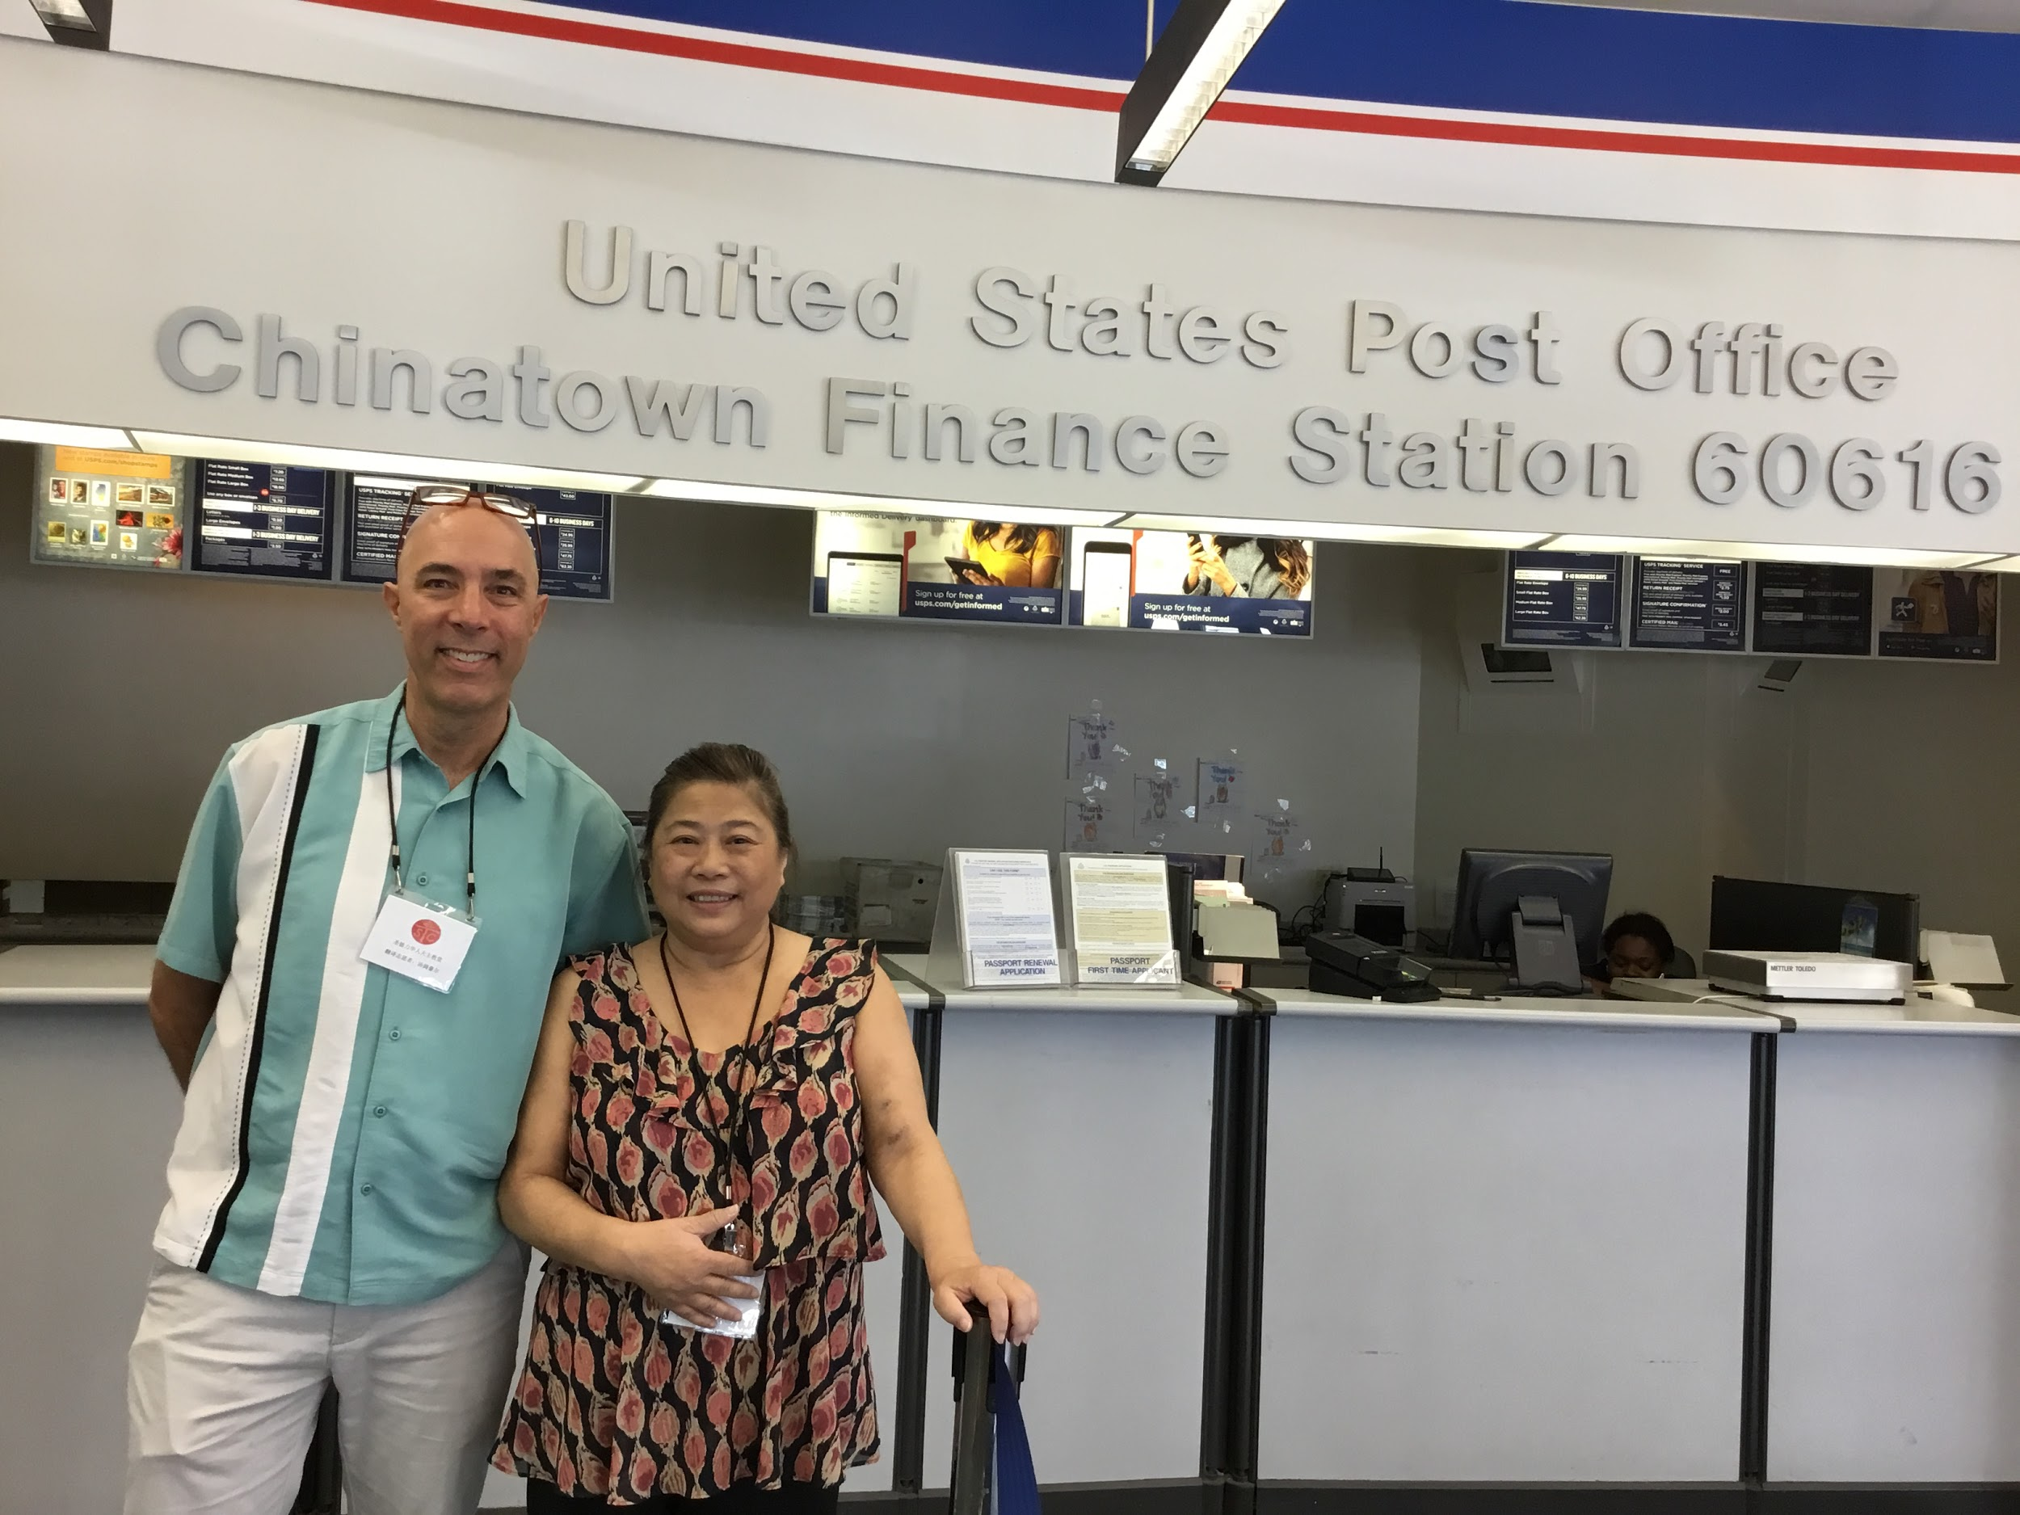
“Are you lazy? Why aren’t you working any more? You used to be so pretty and thin. What happened to you?”

How, you may wonder, could ‘anyone’ ever recover from such a vicious diatribe and reframe this conversation to a more healthy, life-giving tone?

You have to understand that it wasn’t just ‘anyone’ being challenged to offer peace in this potentially violent situation.

It was, instead, a disciple of Jesus who was responding to Christ’s call to translate for patrons at the Chinatown post office as part of our Chinese Apostolate.

“Actually I am retired and have been recovering from a terrible sickness. Nevertheless, God gave me the strength in order to make it out here today to the post office so I could use my translation skills in order to help my community,” the St. Therese volunteer replied.

From this juncture, the conversation took off, catching up on many years of family, professional and personal life information.

After this conversation was complete and the Cantonese-speaking patron made her way out the door, I became curious. “What perspective did your long-time acquaintances have on volunteering?”

“Initially, she probably thought it was a waste of time due to the fact that I was not making money. However, I suspect that on her way home she may have reflected upon her initial cruel comments. I hope she eventually explores why someone like me in my condition might chose to come out and volunteer at the post office,” the volunteer replied.

If you are interested in volunteering as a translator at the post office this summer, please reach out to Perry or Tom. God bless.

Stories From the Chinese Apostolate #2
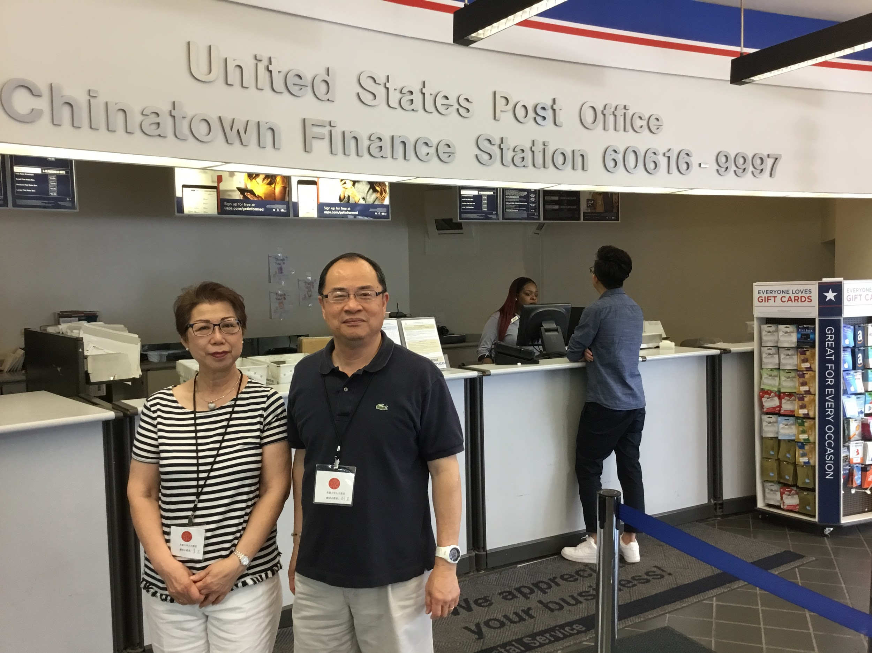

Studies reveal that the most effective way for parishes to build next year’s RCIA class is to leverage opportunities for former RCIA participants to go public with their faith. This does not mean standing on a street corner proselytizing, but rather doing simple acts of charity, like translating at the post office for immigrant families.
Irene Lee, baptised just a couple of years ago, joins Perry Lau, St. Therese RCIA instructor, at the Chinatown on Saturday’s to translate.

“Many recent immigrants come into our local post office without the necessary language skills to navigate our system here.. Recently, for example, I helped a patron who was about to put her mail in the garbage slot correctly put it in the mail slot. She was so grateful that this important letter was put in the right place so it could arrive safely to her loved one in London.”

This past Sunday Irene was delighted to see that one of the customers whom she had assisted actually came to the Sunday liturgy at St Therese. “I am so grateful for the Eucharist,” Irene shared with Perry after mass, “because it helps me when I lose hope. It is easy for widows like me to lose hope. Thanks to Jesus in the bread and wine, I will never lose hope.”

Please help us promote the RCIA. Flyers are available in the entrance area of the Church. God Bless, Perry Lau and Tom Howard.

Stories from the Chinese Apostolate: #3

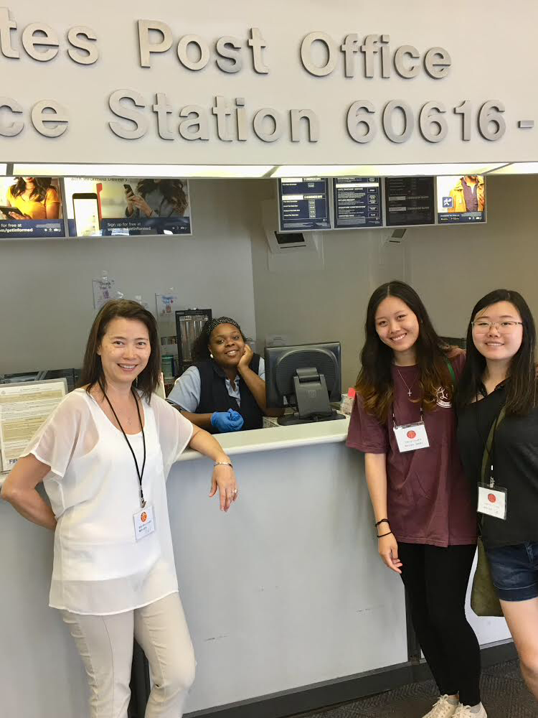

When asked what inspired her to translate at the Post Office, Kalina Pon shared, “I sensed it would be a great way for my daughters and I to spend quality time together. Plus, it helps my daughters fine tune their social skills.”

Like many mothers in Chinatown, Kalina devotes a great deal of her time to her daughters and to family life.

Thanks to St. Therese, where her and her daughter are choir members, and at school, where she faithfully served on the school board for many years, Kalina’s parenting perspectives have matured over time. “I always tell parents, ‘Get involved! As parents, we learn as we go. Thanks to the trust built up through committed relationships at St. Therese, parents have unique opportunities to grow in mind, heart and spirit.”

“All Parents want the best for their children. However, in today’s competitive and fast-paced environment, parents can easily push their children to the brink of exhaustion. Unless parents are careful, they can end up adding, not subtracting, to their children’s anxiety levels.

Kalina has learned that the kids put enough pressure on themselves; that as a mother, she should be a source of comfort rather than stress. Something as simple as having a pot of English tea and biscuits with her children is more effective than constant pressure and nagging. Over a hot cup of earl grey tea, they have built a relationship of trust. “I used to identify with the role of tiger mother. Now, thanks to my Catholic faith, I possess the necessary interpretive skills to reframe this role into something more life-giving.”

If you are interested in volunteering as a translator at the post office this summer, please reach out to PerryYlau@gmail.com or Thoward@sttheresechicago.org. God bless
Stories from Chinese Apostolate #4

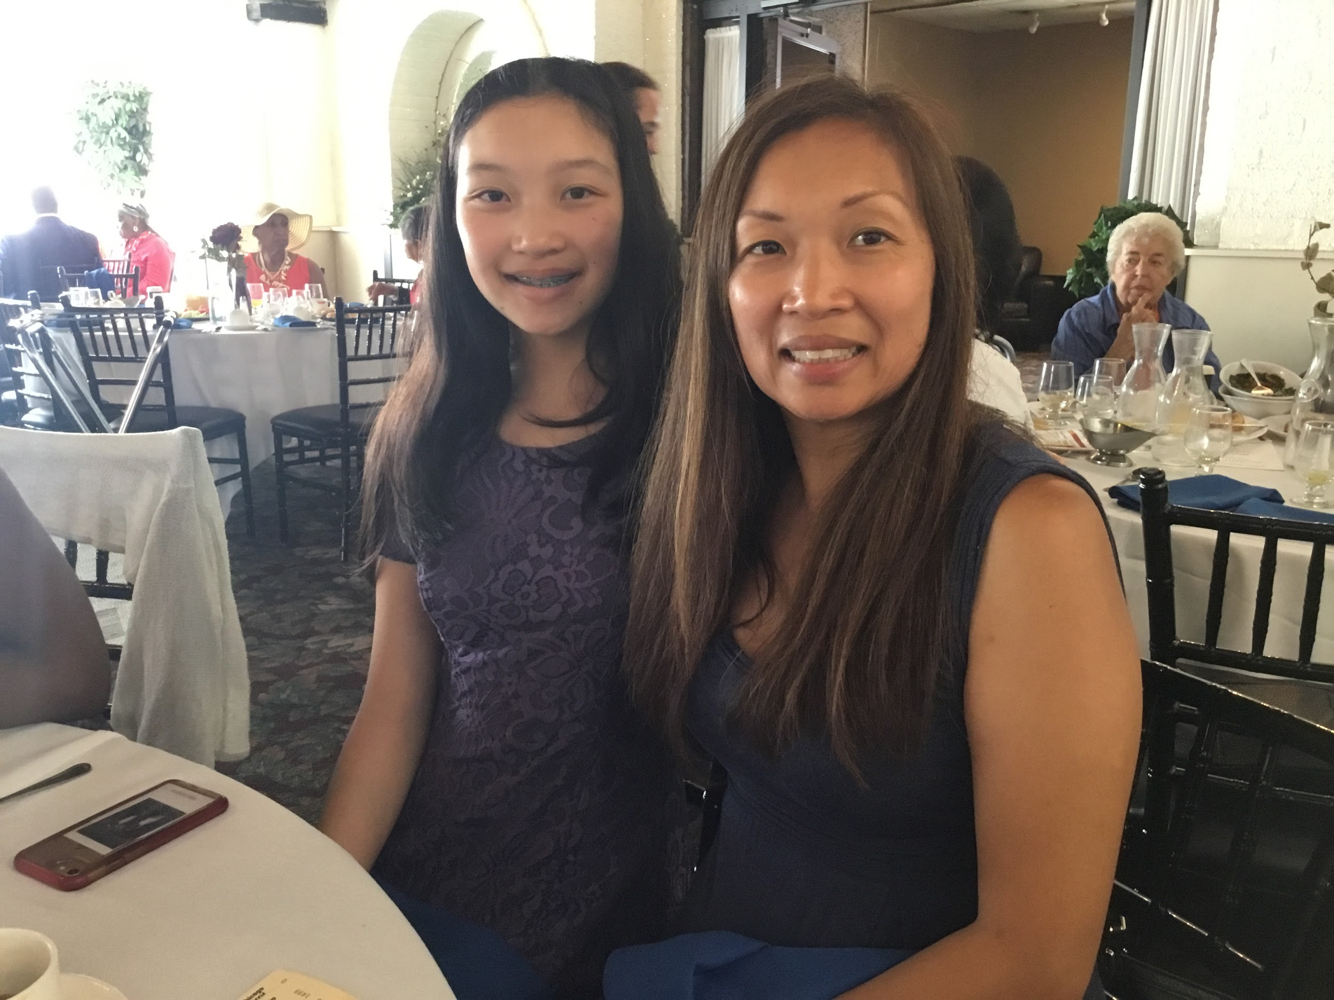
An overlooked but very important statue in our church can be found on the right hand side.

Mary’s mother and Jesus’ grandmother, St. Anne, holds prominence for the Moy family at St. Therese for a very special reason.

“My great-grandmother is responsible for passing on the Catholic faith to me. When I was a child, great grandma always took me to mass. After mass we always looked forward to enjoying some dim sun together. These were some of the most precious moments in childhood,” recalled Elisa Moy, long time St. Therese parishioner.

The resiliency of the Catholic faith is truly amazing in this narrative, for unlike in the case of Jesus, who had the unconditional support for faith formation from both his mother and grandmother. Elisa’s grandmother was her sole link to the faith.

“The first time that my parents ever stepped into St. Therese Church was for my 8th grade graduation. I was also blessed to have them present at my baptism as an adult. Yes, if not for my great grandmother, my husband and I would not have raised our children Catholic. Five generations later, thanks to great grandma, our children were baptised.

Witnessing one’s faith, no matter how mundane or ordinary, can make a huge difference in someone else’s faith life.

Please help us promote the RCIA. Flyers are available in the entrance area of the Church. God Bless, Perry Lau and Tom Howard.

