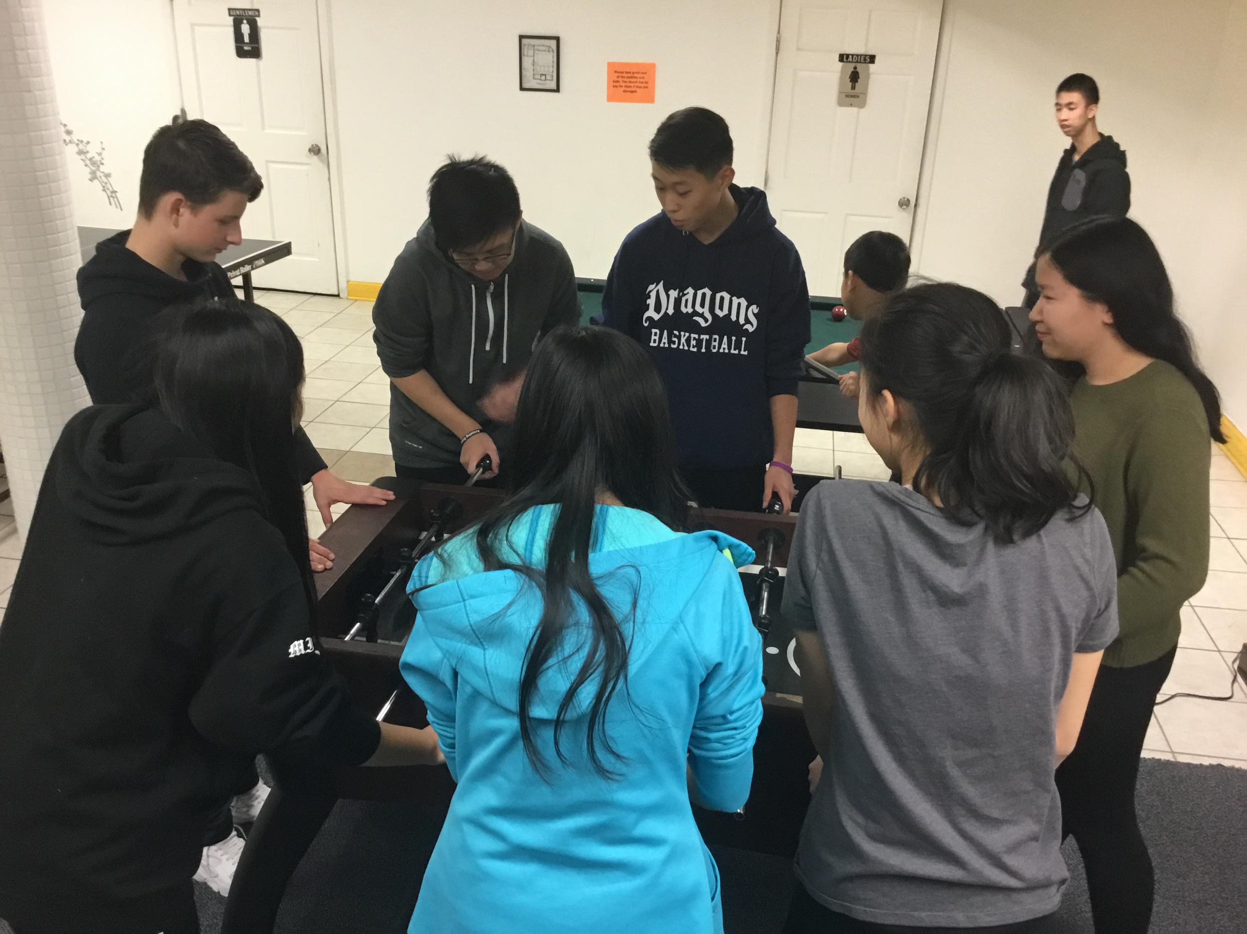
St. Therese Youth Ministry Meeting
When: Saturday, February 3rd, March 3, April 14 and May 5, 2018, 5 p.m.- 7:30 p.m.

Where: St. Therese Parish. We begin with mass then proceed to community room.

Who: Any parish, community or school youth who are willing to make a difference!

Why: Celebrate faith, make new friends, explore ways to belong to community.

Refreshments served!
______________________________
Yes, I give my son/daughter permission to attend the 1/06/18 youth ministry gathering.

____________________________________ ________________________
Parent Signature Youth Name

